**DR VISHWANATH KARAD**

**MIT - WORLD PEACE UNIVERSITY**

**FACULTY OF MANAGEMENT (UG)**

**BACHELOR OF COMPUTER APPLICATION**

**BCA**

**Course:- Project Log Book**

**Course Code :-**

**Course Credits: 5**

**BATCH – 2018-19**

**CONTENTS**

|  |  |  |
| --- | --- | --- |
| **S.No** | **Title** | **Page No** |
|  | Student Information | 3 |
|  | Attendance | 4 |
|  | Evaluation Pattern | 6 |
|  | Submission Deadlines | 7 |
|  | Undertaking | 8 |
|  | Certificate | 9 |
|  | Project Guidelines | 10 |
|  | Synopsis | 13 |
|  | Introduction | 13 |
|  | Statement of the problem | 13 |
|  | Scope of the study | 13 |
|  | Need of the study | 14 |
|  | Objectives of the study | 14 |
|  | Feasibility Study | 14 |
|  | Technology Used | 14 |
|  | Requirement Gathering | 14 |
|  | System Design – DFD, ERD,UML Diagrams, Activity Diagram, Sequence Diagram | 16 |
|  | Data Dictionary | 23 |
|  | User Interface Design | 26 |
|  | Business Logic | 28 |
|  | Additional features implemented | 32 |
|  | Future Enhancements | 33 |
|  | Glossary | 34 |

**STUDENT INFORMATION**

|  |  |  |
| --- | --- | --- |
| **S.No** | **Particulars** | **Details** |
|  | Student’s Name | **Prateek ,Yogesh,Bharat** |
|  | Roll No | **58,76,49** |
|  | Team Member’s Name |  |
|  | Team Member’s Roll No |  |
|  | Guide’s Name |  |
|  | Programme Name |  |
|  | Trimester |  |
|  | Course Code |  |
|  | Project Title | **Packers & Movers** |

**ATTENDANCE**

|  |  |  |  |  |
| --- | --- | --- | --- | --- |
| **S.No** | **Date** | **Task Assigned** | **Remarks** | **Guide’s Signature** |
|  |  |  |  |  |
|  |  |  |  |  |
|  |  |  |  |  |
|  |  |  |  |  |
|  |  |  |  |  |
|  |  |  |  |  |
|  |  |  |  |  |
|  |  |  |  |  |
|  |  |  |  |  |
|  |  |  |  |  |
|  |  |  |  |  |
|  |  |  |  |  |
|  |  |  |  |  |
|  |  |  |  |  |
|  |  |  |  |  |

**ATTENDANCE**

|  |  |  |  |  |
| --- | --- | --- | --- | --- |
| **S.No** | **Date** | **Task Assigned** | **Remarks** | **Guide’s Signature** |
|  |  |  |  |  |
|  |  |  |  |  |
|  |  |  |  |  |
|  |  |  |  |  |
|  |  |  |  |  |
|  |  |  |  |  |
|  |  |  |  |  |
|  |  |  |  |  |
|  |  |  |  |  |
|  |  |  |  |  |
|  |  |  |  |  |
|  |  |  |  |  |
|  |  |  |  |  |
|  |  |  |  |  |
|  |  |  |  |  |

**EVALUATION PATTERN**

|  |  |  |  |  |
| --- | --- | --- | --- | --- |
| **S.No** | **Assessment** | **Duration (hrs)** | **Remarks** | **Signature** |
|  | Synopsis | 5 |  |  |
|  | Requirement Gathering | 10 |  |  |
|  | Design | 10 |  |  |
|  | Data Dictionary/ GUI | 15 |  |  |
|  | Business Logic | 35 |  |  |

**SUBMISSION DEADLINES**

|  |  |  |  |  |
| --- | --- | --- | --- | --- |
| **S.No** | **Particulars** | **Date of**  **Submission** | **Remarks** | **Signature** |
|  | Synopsis |  |  |  |
|  | Requirement Gathering |  |  |  |
|  | System Design |  |  |  |
|  | User Interface Design |  |  |  |
|  | Internal Evaluation - I |  |  |  |
|  | Internal Evaluation - II |  |  |  |
|  | Internal Evaluation (Final) |  |  |  |
|  | External Evaluation (Final) |  |  |  |

**UNDERTAKING**

I declare that the work presented in this project titled “_______________________________”, submitted to ________________Department, Faculty of Management (U.G), M.I.T. World Peace University, Pune for the award of the Bachelor of Computer Application degree, is my original work. I have not plagiarized or submitted the same work for the award of any other degree. In case this undertaking is found incorrect, I accept that my degree may be unconditionally withdrawn.

Date : __________

Name : ____________________________

Signature:__________________________

**CERTIFICATE**

This is to certify that Mr./Ms.______________________________________________________of ________________Department, Faculty of Management(U.G), M.I.T. World Peace University, Pune hassuccessfully completed the project work titled ______________________________________________ in partial fulfillment of requirement for thecompletion of ___________________course as prescribed by the University.This project report is the record of authentic work carried outby him/her during the period from ___________ to ___________. He/She has worked under my guidance.

Signature Signature

Name: Name:

Project Guide (Internal) Course In-charge

Date: Date:

**PROJECT GUIDELINES**

* Contents of Project report

The Project Report should contain the items as outlined below and is to be presented in the order as listed.

* Number of Copies to be submitted to the Department
  + Number of group members plus one copy has to be prepared.
  + Hard copy of the report is to be submitted to the Department after corrections done as suggested by guide/Department at any time when report submission is called by guide/Department.
* Requirements for Report
* Writing Your report should meet following standards:
  + Font Name: Times New Roman(for normal text)
  + Font Size: 12 pt (for body of text)
  + Left Margin: 1.5 inch Right Margin: 1.25 inch Top Margin: 1.25 inch Bottom Margin: 1.25 inch
  + Line Spacing: 1.5 Paragraph Spacing: 18 pt
  + Follow following standard for headings Font Size: Chapter title 16 pt (Bold) title case• Heading e.g. 1.1 14 pt(Bold) title case• Subtitle e.g. 1.1.1 12 pt (Bold) title case• Subtitle e.g. 1.1.1.1 12 pt (Bold) title case•
  + There should be uniformity in writing headings and sub-headings in all chapters.
  + To indicate a figure, write below the figure and the format should be Fig. 1.5.
  + To indicate a table, write above the table and the format should be Table 1.5.
  + All the figure captions and table captions should be 12 size, bold and title case.
  + Figures used in the report should not be blur.
* Binding Specifications
  + Reports are to be Spiral bound

**SYNOPSIS**

Packers and movers is a transport management system used for the transport for the users of their orders. We provide best and reliable services in relocating. It works according to the needs and requirements of user, and provides desirable result. We use the best packing materials to pack clients good in such a way that all the good remain safe during transport.

The client after logging into our website can book our devices of transportation for of transportation. We provide transportation for household goods and commercial shifting services for almost all kinds of goods

The cost is calculated based on distance and delivery is done usually within a week. The payment is done after the completion of delivery.

**OBJECTIVE**

-to reduce paperwork and administration expenses

-reduce time and money spent on bulky paperwork

-to provide on efficient freight execution platform

-Provide involving functionality

-Provide for better fright settlement of audit and pay

**SCOPE OF SYSTEM**

Millennials in India are constantly on the move today they are willing to move around for better career opportunity. To cater for their moving requirement, we aim to provide user – friendly interface, provide safe and affordable services in field of packers & movers. We aim to minimize both the costs and risks involved.

**PROPOSED SYSTEM**

packers and movers is an online platform for secure seekers and services providers where all the companies are available at single site as web portal and they do communicate directly with service seekers. In Packers & Movers we have listed excellent packing moving service providers of India, household shifting and relocation service providers, car transportation, office, home, shop, industrial or commercial shifting.

**MODULE:** user

User can get login with a valid username and password and view all the services provided by the agency. Users can book the services online for location moving from one place to another.

**MODULE:** admin

Admin gets login by valid username and password admin can view the request sent by clients. Admin can view the suggesting and feedback given by the client admin can view all registered Packers details admin verifies the registration details and provide services accordingly.

**REQUIREMENT GATHERING**

TEHNIQUE USED – (fact finding, research and survey)

-A survey conducted on Packers & Movers category of local services in the year 2016 – 17 revealed several instructing trends. The study showed that 44% up survey in online request for packers and movers across India in the last one year.

The study covered 8 key metropolitan cities

-Delhi

-Mumbai

-Chennai

-Hyderabad

-Kolkata

–Ahmedabad

-Pune

The 3 markets have seen the minimum growth are: Pune (185%), Kolkata (76%) and Ahmedabad (66%) the Packers & Movers industry outside India has growth of 72% Packers & Movers is a high value industry in the $200 billion local service market in India it is clearly evident how this industry is in demand.

Therefore, we packers and movers provide the transportation services to such customers

**OBJECTIVES**

* Admin management
* Client / customer management
* Online payment
* Calculate of cost distance wise
* Email alerts for payment & order detail
* Order tracking
* Managing customer details
* Review & rating options
* Help & support for customers
* Search engine for comparison of agencies

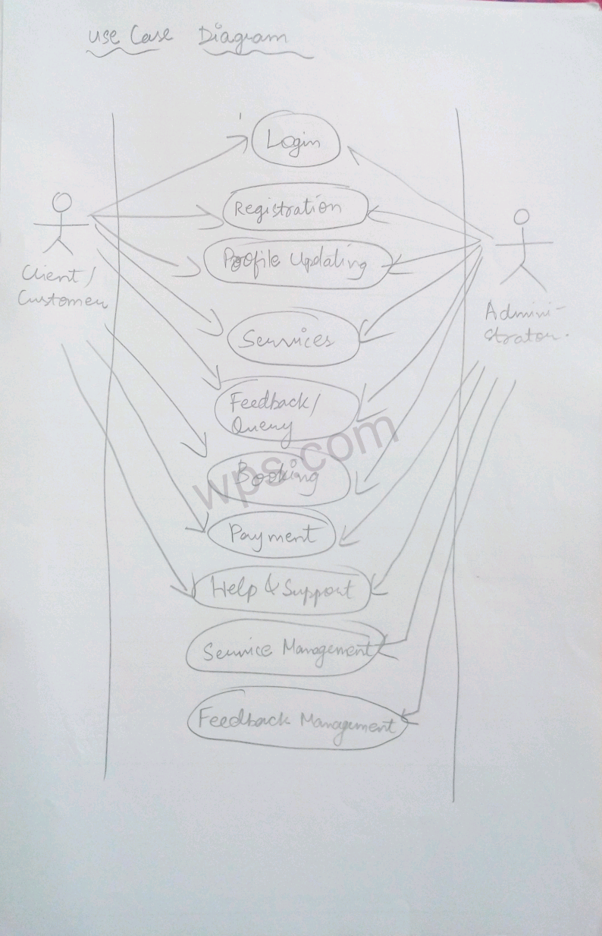

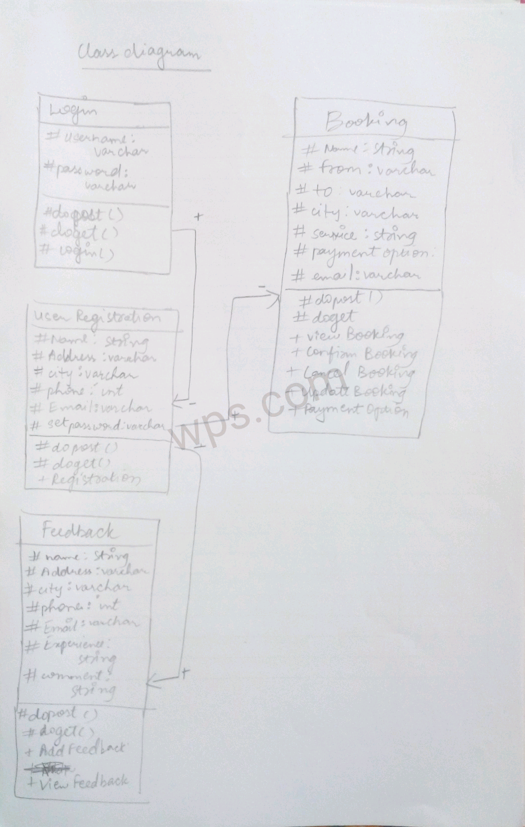

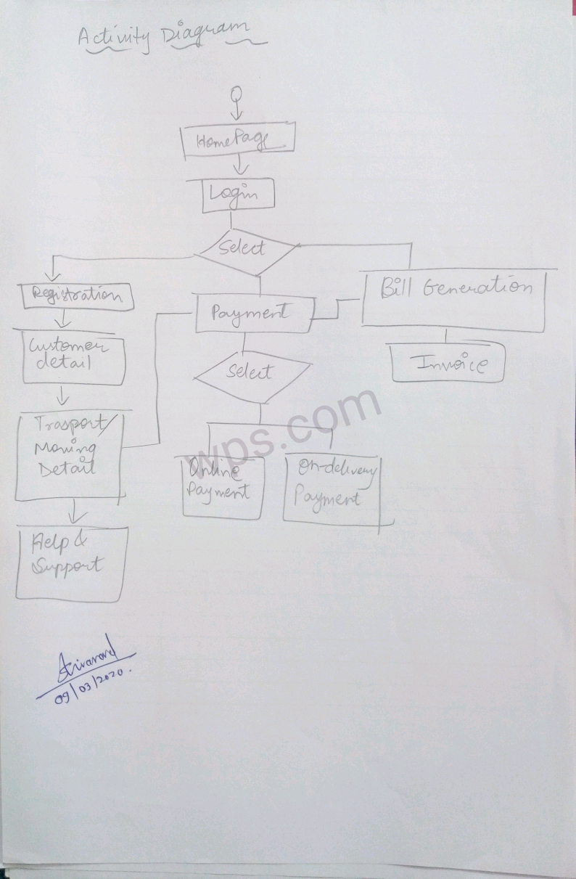

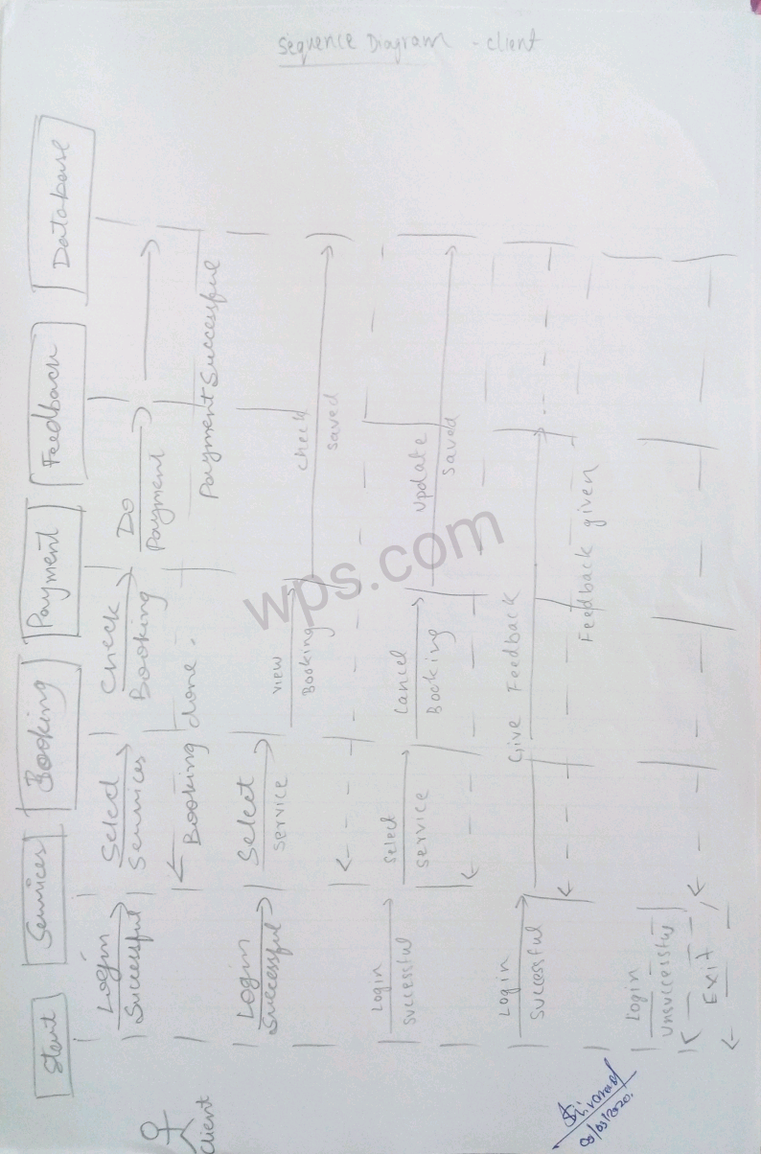

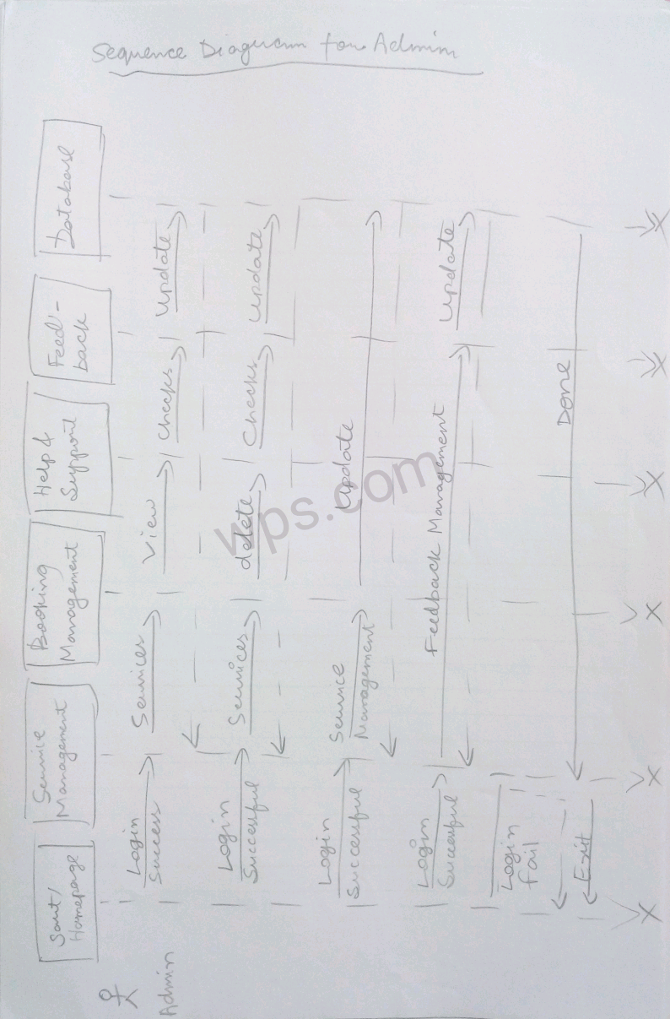

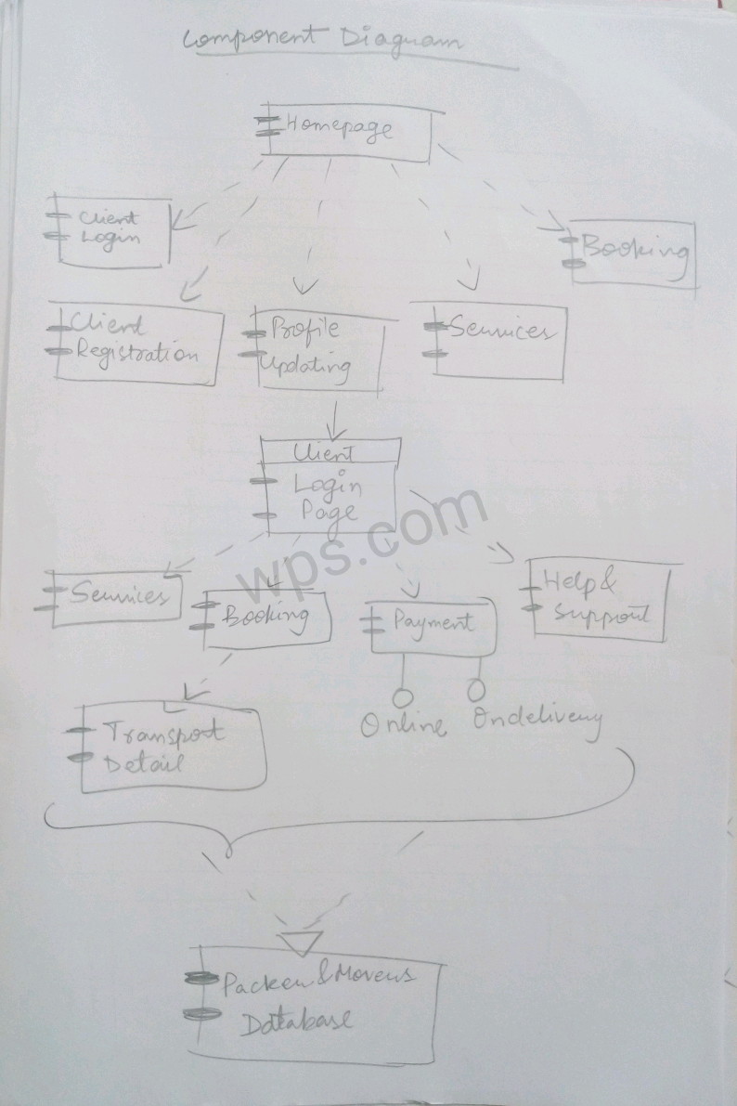

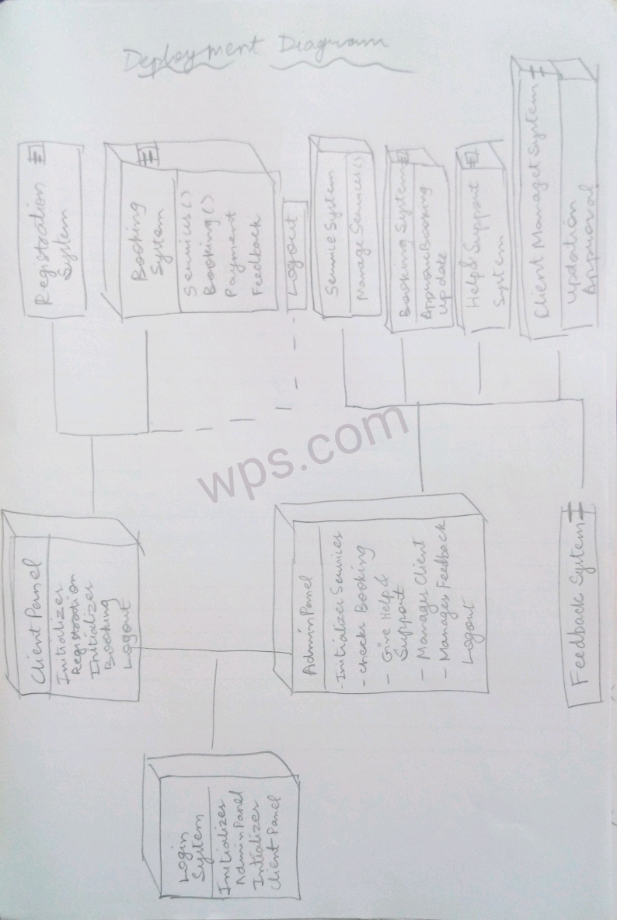

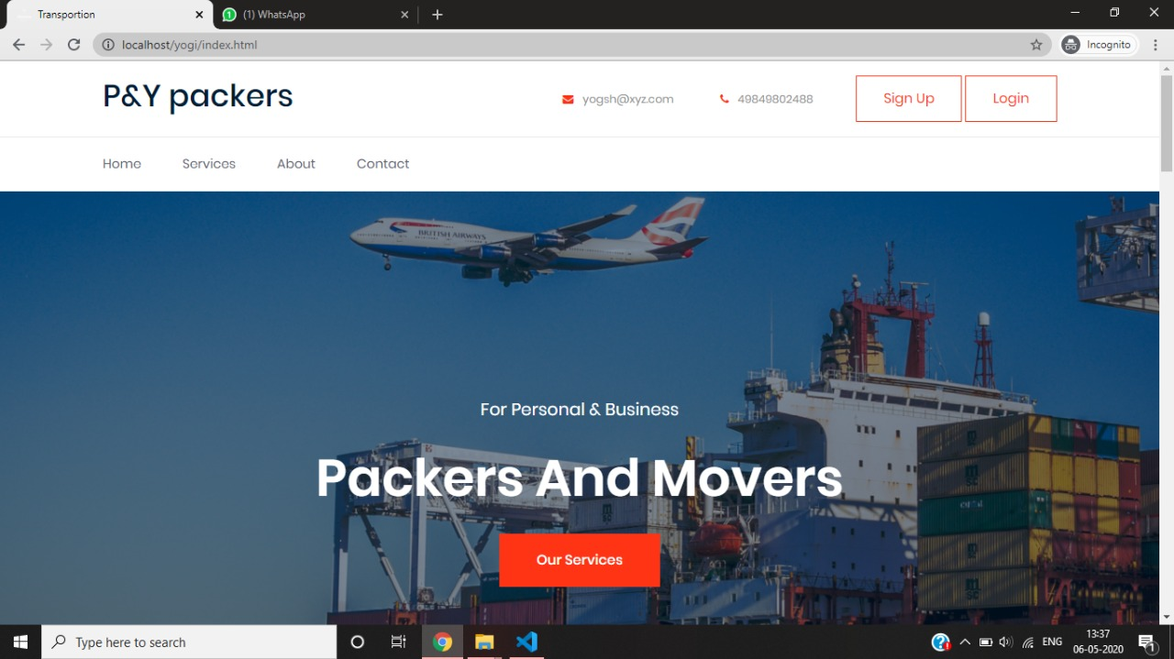**USER INTERFACE DESIGN**

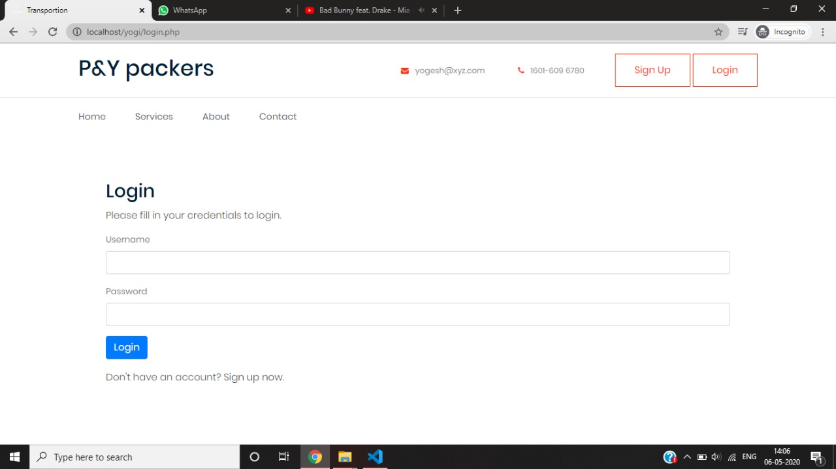

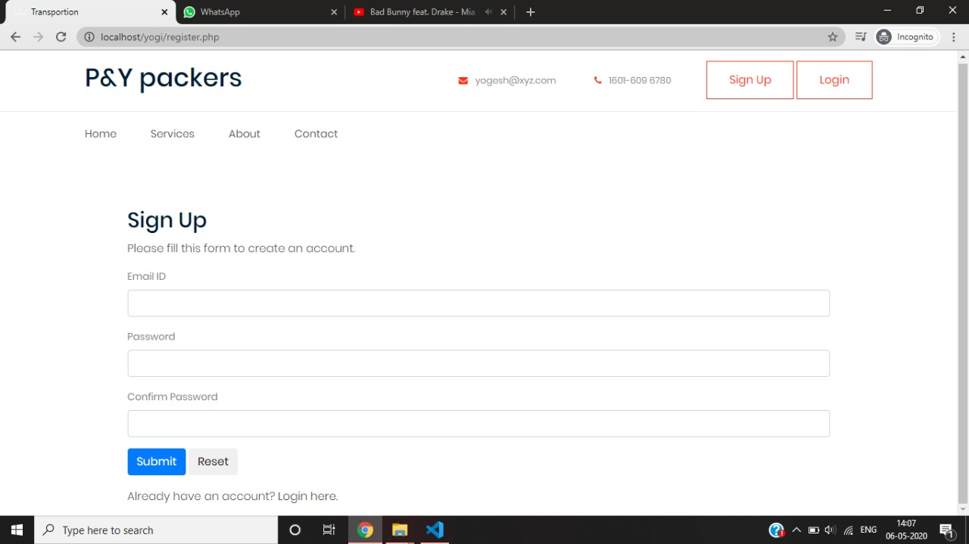

**DATA DICTIONARY**

**Admin Detail**

|  |  |  |  |  |  |
| --- | --- | --- | --- | --- | --- |
| **Sr no.** | **Name** | **Data type** | **Size** | **Constraint** |  |
| **1** | **Admin_ID** | **Int** | **11** | **Primary key** |  |
| **2** | **Admin_username** | **Varchar** | **30** | **Not null** |  |
| **3** | **Password** | **String** | **30** | **Not null** |  |

**Booking Details**

|  |  |  |  |  |
| --- | --- | --- | --- | --- |
| **Sr no.** | **Name** | **Data Type** | **Size** | **Constraint** |
| **1** | **Username** | **Varchar** | **25** | **Not null** |
| **2** | **User_Id** | **Int** | **23** | **Primary key** |
| **3** | **From** | **Varchar** | **22** | **Not null** |
| **4** | **To** | **Varchar** | **30** | **Not null** |
| **5** | **City** | **Varchar** | **30** | **Not null** |
| **6** | **Services** | **Varchar** | **44** | **Not null** |
| **7** | **Payment** | **Varchar** | **55** | **Not null** |

**User Regestration**

|  |  |  |  |  |
| --- | --- | --- | --- | --- |
| **Sr no.** | **Name** | **Data Type** | **Size** | **Constraint** |
| **1** | **Name** | **Varchar** | **25** | **Not null** |
| **2** | **Address** | **Varchar** | **23** | **Not null** |
| **3** | **City** | **Not null** | **22** | **Not null** |
| **4** | **Email** | **String** | **30** | **Not null** |
| **5** | **Phone** | **Int** | **30** | **Not null** |
| **6** | **Username** | **Varchar** | **44** | **Primary name** |
| **7** | **Password** | **String** | **55** | **Not null** |

**Feedback Detail**

|  |  |  |  |  |
| --- | --- | --- | --- | --- |
| **Sr no.** | **Name** | **Data Type** | **Size** | **Constraint** |
| **1** | **Name** | **Varchar** | **25** | **Not null** |
| **2** | **Email** | **String** | **23** | **Not null** |
| **3** | **Phone** | **Int** | **22** | **Not null** |
| **4** | **Comment** | **String** | **30** | **Not null** |

**Payment Detail**

|  |  |  |  |  |
| --- | --- | --- | --- | --- |
| **Sr no.** | **Name** | **Data Type** | **Size** | **Constraint** |
| **1** | **Name** | **Varchar** | **25** | **Not null** |
| **2** | **Payment** | **Float** | **23** | **Not null** |
| **3** | **Bill Gen.** | **String/Float** | **22** | **Not null** |
| **4** | **User_Id** | **String** | **30** | **Primary Key** |

**BUSINESS LOGIC**

**TEST CASES**

**ADDITIONAL FEATURES IMPLEMENTED**

**FUTURE ENHANCEMENTS**

**GLOSSARY**